Student Union of LAB University of Applied Sciences KOE
Code of Conduct
Set of ethical principles

Approved at Board Meeting 13.1.2022
Approved at Representative Council Meeting 27.1.2022

Table of content

Introduction
Harassment, discrimination and inappropriate behavior
Tutoring
Harassment contact person
Operating instructions

Introduction

KOE's Code of Conduct is an operating guidebook for student union events and tutoring.

The Code of Conduct is based on KOE's values ​​- student oriented approach, equality and community. All activities of KOE are regulated by the Declaration of Equality. The purpose of this guidebook is to create clear rules for events and tutoring that will ensure a positive and safe student community. This guide provides concrete guidelines for resolving possible harassment and discrimination situations. KOE has zero tolerance for harassment, discrimination and misuse. The Code of Conduct applies to all participants in KOE's activities and events.

Harassment, discrimination and inappropriate behavior

According to the Finnish Occupational Safety and Health Administration (March 22, 2021), harassment includes frequent threatening, intimidation, malicious or suggestive messages, derogatory and mocking phrases, questioning of one’s reputation or position, and sexual harassment.

According to the Non-discrimination Ombudsman (22 March 2021), discrimination happens if someone is being treated less favorably than another based on their personal qualities. Every person has the right to equal treatment and discrimination is prohibited in multiple Finnish national laws, such as the Non-discrimination Act and the Criminal Code of Finland, as well as in the international human rights treaties. Discrimination is also an instruction or command to discriminate.

According to the definition of the the Center for Occupational Safety in Finland (22.3.2021), inappropriate treatment can take form in, for example, bullying, neglecting, belittling, ignoring, isolating, blackmailing, mocking one’s private life, personality traits or qualities, threatening, discriminating or favouring. Harassment, discrimination and inappropriate behavior can go unnoticed when a diverse group of people participate in it together. Respect for freedom of speech and opinion is the first step towards a non-discriminatory and non-harassing events and tutoring activities.

Situations and events where alcohol is used can be oppressive especially for those who do not drink alcohol. The use of alcohol is everyone's choice and no one's choice should be questioned, judged or criticized under any circumstances. Everyone is responsible for their own behavior.

Social media is an integral part of KOE’s operations. The information about events and tutoring is communicated by both KOE representatives and students. KOE student union announces on its Facebook event page whether there will be photos taken during the event itself. If you do not wish to appear in the pictures, let the event organizer know. Written and graphic communication online can be challenging. Even a benevolent image can unintentionally offend someone or even cause an experience of harassment or discrimination. The rules of good taste and respect towards others should be remembered and followed in all social media communications.

Tutoring

KOE student union choses and trains tutors for their tasks and responsibilities. Tutoring is a key position of trust in the university community. A professional touch for tutoring is expected from all the members of the tutoring team. The tutor must act discreetly and remember professional confidentiality. Tutoring is a special position of trust, marked by a yellow tutor shirt. All students must be treated equally by their own tutors.

When wearing a tutor shirt, the tutor's actions are comparable to working in a work community. This means the nature of events organized needs to be non-alcoholic.
Tutor shirts should not be worn while intoxicated or while in a bar.

Tutors must remember that they are seen as tutors even when they are not wearing a tutor shirt. New students meet tutors mainly as tutors, and may not get to know them otherwise, for example as friends. If tutors encounter their new students without wearing a tutor shirt, they should remember a professional approach to tutoring. It is very important that new students are informed from the beginning about the duties, tasks and responsibilities of their tutor.

Harassment contact person activity

Each event organized by the KOE student union has a harassment contact person. Harassment contact persons are KOE representatives of different genders. Harassment contact persons are not authorities, but either specially trained students or student union employees. KOE’s harassment contact persons help, support, advise and guide even outside of events. It is the duty of the harassment contact persons to listen without judging and if asked so, to intervene in any harassment, discrimination or inappropiate behavior situations occured.

During the events harassment contact persons will be available for contact face-to-face, by telephone and / or by email depending on the situation. Information on event-specific harassment contact persons can be found in the event description box. Contact information for all harassment contact persons can be found on the KOE website. When contacting it is a good to keep in mind that technical and timing challenges could affect the availability of a harassment contact person. A person who has experienced harassment, discrimination or inappropriate use at an KOE event may contact the event's harassment contact person even after the event is over.

Upon the contact the harassment contact person and the person who experienced the harassment will discuss the situation and possible further actions. The conversations are always confidential and no action would be taken without the permission of the person who experienced the harassment. If wish so, the person who has experienced harassment, discrimination or misuse may refrain from demanding further actions and may only seek for the support in from of discussion from the harassment contact person.

Operating instructions

If you experience harassment, discrimintaion or any inappropriate behavior, contact harassment contact person
- Tell what has happened or what you have experienced.
- Discuss with the harassment contact person about how the situation can be solved

If you see or experience a situation where someone else is harassed, discriminated or they experience inappropriate behavior and you want to report that, contact harassment contact person
- Tell what has happened or what you have seen
- Harassment contact person can contact both sides of the situation you have witnessed, if you wish so

Upon receiving the information considering harassment situation, harassment contact person acts confidentially with the consent from the harassed person

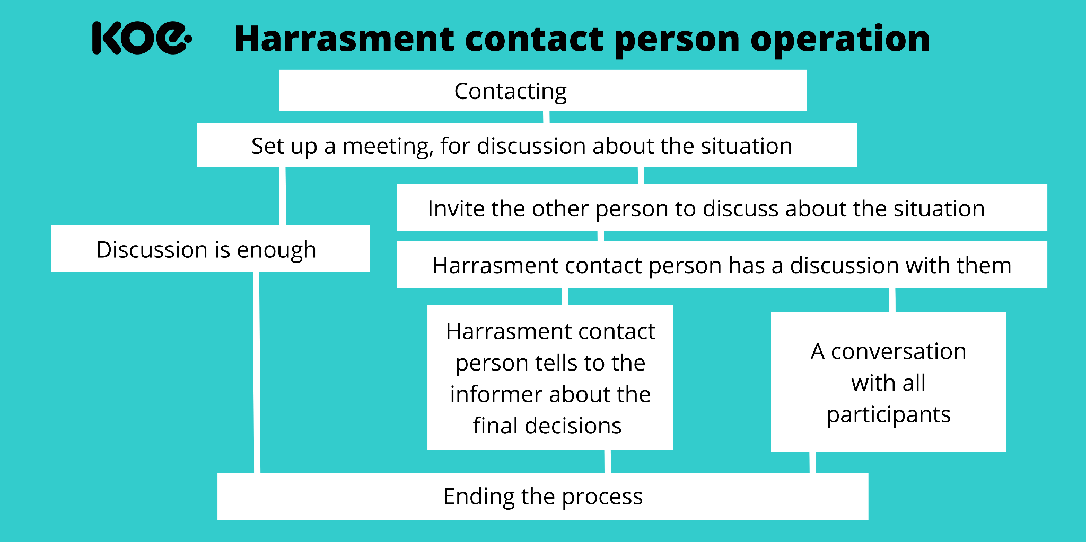

The harassment contact person can:

- Contact both sides of the harassment situation individually to discuss it with them
- Organize a meeting for the parties of the harassment situation for further discussion
- Advise the parties of the harassment situation to contact support services offered by different operators, such as telephone servicesMieli ry's Crisis Helpline.

In a situation where KOE representative (Tutor, Member of the Board, Member of the Representative Council, Member of the Staff) harasses, discriminates or otherwise behaves inappropriately, the harassment contact person may:

- Contact and discuss the situation with the various parties to the harassment situation.
- Provide an opportunity for the parties to the harassment situation to discuss the situation via meeting
- Assemble a group to decide upon further measures.

The representative of KOE can also be dismissed at its discretion in accordance with the rules and agreements.

